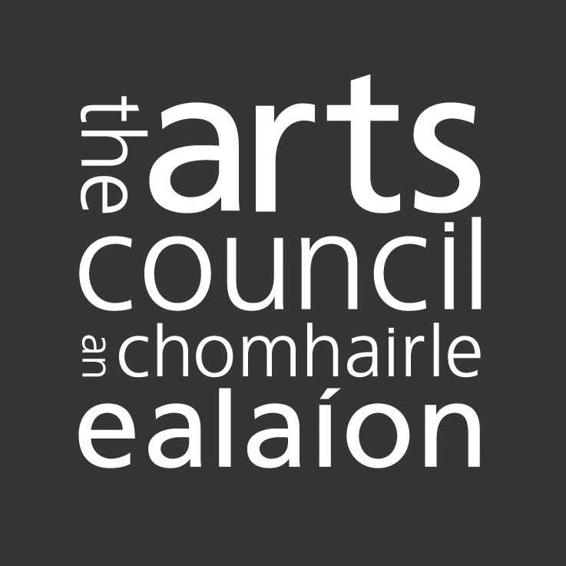

OPEN CALL PROJECT AWARD
FINAL REPORT FORM

The Arts Council would like to know how the provision of an award has helped you, and how it may have affected your work and your career.

Please take some time to complete this and return it to the Arts Council. Your information will help us to document and to improve the quality of our supports for other artists, and to evaluate their impact relative to our strategic priorities. Please add extra pages as necessary.

We are also very interested to receive any promotional material associated with the proposal for which you were given an award, and good quality photographs, slides, video or audio tapes, reviews (as appropriate).

PLEASE NOTE
If your Open Call Award is under €100,000 you should complete sections: 1-12 and 14

If your Open Call Award is over €100,000 you should complete sections: 1-2, 4, 6-8, 10-14

The Declaration of Assurance (Section 14) section at the end of this form must be signed by the award recipients*

1. CONTACT DETAILS

ARN

Application Number

Name

Address
Date and amount of award

2. APPLICATION PROCESS
How did you find out about the award?  - Website  - Word of Mouth  - Through the Arts Council  - Through the Media | - Artists’ representative/resource organisation  - Arts Council email newsletter  - Other (specify)
Was the application process reasonable? (i.e., forms, published criteria, timescale, efficiency, timescale of the award, interview process)

If not, how could it be improved?

Were the Arts Council’s objectives in making the award clear?

Were the artistic criteria clear and workable?

Were you happy with the amount of the award – if not please detail how this affected your proposal?

3. PROJECT AIMS
Please outline the aims of your project and describe if/how the aims were met or exceeded?

4. PROFESSIONAL DEVELOPMENT
How did the award enhance your or your organisation’s artistic or professional development (for example in terms of specific experiences or projects, opportunities for enhancing skills, collaborations with others etc.)?

5. CRITICAL AND AUDIENCE RESPONSE
Please provide a summary of critical and audience response, including audience numbers.

6. INTERNATIONAL DIMENSION
Did your proposal have an international dimension; if so can you describe what form this took and how it has benefited your work?

7. RESEARCH AND DEVELOPMENT
Did your project undertake phases of research and development; if so please outline what took place and how this supported the development of your work?

8. PARTNERSHIPS
Please briefly outline any collaborations or significant partnerships that were integral to your project delivery. What worked well and how will these partnerships benefit you or your organisation in the future?

9. FINANCIAL REPORT
You are also required to submit a detailed Income and Expenditure Account as part of the final report. Please provide details here of any significant changes to the project budget.

10. LEGACY
What do you consider is the impact of your project? For example, has your project developed artform practice, created new opportunities for public engagement, provided new opportunities for artists or your organisation?

11. FUTURE PLANS
What plans (if any) do you have to further your proposal/project?

12. ANY OTHER COMMENTS

13. DETAILED PROJECT REPORT:
Please provide a detailed project report which includes:
- Project aims and objectives and whether these were met.
- A full account/evaluation of all aspects of the project from artistic, financial, marketing/engagement and project management perspectives.
- A project schedule
- A summary of critical and audience response
- Lessons learned from the project (including whether the project was realised as planned)
- Any Project Outcomes

14. DECLARATION OF ASSURANCE*

A declaration of assurance signed by two responsible persons involved with the funded activity is required. This is to certify that the Arts Council funding was used for the purpose for which it was granted and that any conditions attached to the funding were met. Where the Funding is less than €25,000 per annum the name of one responsible person is sufficient.

I certify that the Arts Council funding was used for the purposes for which it was granted and that any conditions attached to the funding were met. Additionally, where I am in the receipt of other sources of public funding I certify that there has been no duplication in the use of public funding for the same activity.

Name: Date:

Name: Date:
(Typed names are acceptable)

